# Introduction

Over the span of twenty years, the growth of the internet has contributed to both businesses and consumers globally in a number of ways. The capacity to produce and use services instantly is one of its main advantages. The Internet of Things (IOT) has recently come to light as a potential technology that offers comparable benefits by altering the workplace and boosting users' perception and capabilities (Farooq et al., 2020) . The Internet of Things (IOT) offers a range of solutions in a number of different industries, including healthcare, retail, traffic management, security, smart homes, smart cities, and agriculture.

The successful control of energy is one of the main challenges in such an IOT enabled smart city and smart home setting because of increasing the demand of electricity with the expanding of population. Public lighting currently uses 10% of the entire amount of electricity distributed (Sikder et al., 2018). This article focus on IOT enabled Smart Lighting System for smart cities and homes with the use of WIFI module which helps to manage excessive use of electricity.

# II. Literature Review

## Internet of Things (IOT) and its applications

The Internet of Things (IOT) is a new impression that provides a variety of creative services for the coming wave of technological development. It makes it possible for the seamless connection of the digital and physical worlds, creating countless opportunities for Internet of Things applications. To fully realize the potential of IOT, several hurdles still need to be overcome despite the substantial joint efforts of standardization organizations, industry partnerships, researchers, and others. These matters cover a wide range of topics, such as IOT's effects on societal issues and the environment as well as enabling technology, applications, and business models. (Čolaković & Hadžialić, 2018)

In order to improve the safety, efficiency, and comfort of our lives, the Internet of Things has modernized how critical and non-critical systems are accomplished (Ande et al., 2020) . IOT technology has a massively good influence on our lives as a result.

## Innovations Features in Modern Computing

Service-based business models have appeared as a consequence of the Internet of Things (IOT), which creates it possible to watch and control numerous systems, including machinery, cars, and processes, remotely. But employing IOT can be challenging for businesses in developing and intermediate economies, particularly when it comes to utilizing technology and the need for a new business policy. (Haaker et al., 2021)

An international network of machines and devices that can link with one another has been made possible by the Internet of Things (IOT), and this new pattern is what is motivating digital revolution in industries. (Lee, 2019)

## IOT Security Challenges

Because of the growing number of computer devices, IOT has just underway to gain extensive traction. However, one of the key IOT challenges that stakeholders continue to raise and the main question they ask is still security, which has the potential to slow down the adoption of IOT. (Rekha et al., 2023) The telecommunications zones are being drastically altered by network softwarization, which may be able to support services with higher value. A widespread range of security vulnerabilities posed by IOT devices may be managed by network infrastructures thanks to the security enablers that software-defined networking and NFV (Network Function Visualization) can play. (Molina Zarca et al., 2018)

## Current and Future trends in IOT

Currently, it is expected that the Internet of Things (IOT) will have a significant influence on both the personal and commercial worlds. IOT breakthroughs in fields like e-health, smart homes, and intelligent education significantly improve quality of life on a personal level. Automation, effective supply chain and transportation management, remote monitoring, and logistics are just a few of the professional uses for IOT. (Shafique et al., 2020)

There will likely be a huge rise in the number of gadgets linked to the internet by 2025, when it is predicted that every item will at least have the capacity to be connected to the internet. According to Cisco, the number of internet-connected gadgets will reach an astonishing 500 billion by 2030. Similar predictions were made by Telefonica in 2013 that by 2020, 90% of automobiles would be online (Roman-Castro et al., 2018) . The number of linked vehicles worldwide is expected to hit 250 million by 2020, according to a 2015 poll, which represents a 67% increase over earlier estimates.

# **Technical Development**

Intelligent urban lighting is developing rapidly due to the convergence of several technological revolutions. Digitization of light through a revolution in light-emitting diodes (LEDs) as light sources. LEDs are rapidly being replaced by LEDs with shorter lifespans and fewer LEDs. Outdated light sources that are efficient but difficult to control, such as high intensity metal halide and sodium discharge lamps, fluorescent and incandescent lamps. New developments in lighting systems also open up unexpected new paths using light for communication, reorientation, cultural, artistic and civic purposes representation and branding. Color Control enables these applications. Different resolution levels and controllable pixel city scale as well High-bandwidth communication via LiFi.

## The Product Aim

The main goal of my products is to bring new and unexpected possibilities identity spatial design with interactive and animated night scenes for parties and parties. An expression of the values ​​that a city and its citizens want to instill in themselves and others visitor. It is estimated that the suggested product will help to utilize the excessive use of electrical energy, improve the energy efficiency by using automated and remote control, and help to uplift the economic condition of a particular country and so on.

## The Product Objectives

Some of the goals of Internet of Things based on smart lighting system are discussed below:

* Improve the living standard of people.
* It has a longer life span for 35,000 to 50,000 hours.
* Easy to use and customized as our need and desire.
* Energy saving and reduce the excessive use of electrical energy.

The flowchart (Figure.1) illustrates the information of system’s flow in PIR sensor. Firstly, the procedure is initialized. Secondly, read the PIR value. If the PIR value is one, the light will glow brightly; otherwise, it will glow dimly. The process is now complete.

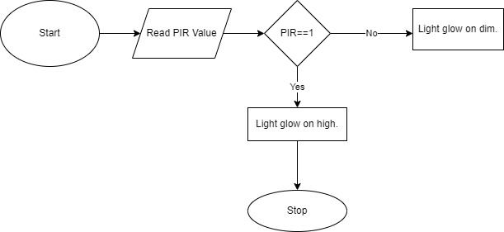

Figure 1: PIR Sensor Integration of Smart Lighting System.

The flowchart (Fig.2) illustrates the information of system’s flow in LDR sensor. Firstly, the procedure is started. Then, read the LDR value of the system. If the LDR value is less than fifty then the message send to the control room with the help of the Wi-Fi module. Finally, the procedure is end.

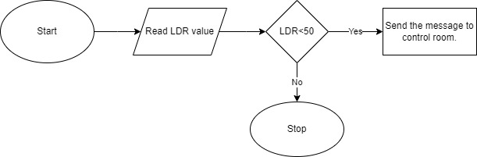

Figure 2: LDR Sensor Integration. Of Smart Lighting System.

## The Product Working Mechanism.

Various sensors like LDR sensor and PIR sensor are used in utilization of electrical energy smart lighting system to take the input from the surroundings. An Arduino Uno is the central part of the system which operates and connects various parts of the system. LDR sensor, PIR sensor, a Wi-Fi module such as ESP8266, a LEDs, and an Arduino Uno as a central part of the system. A Wi-Fi module is connected to the Arduino board. Wi-Fi module helps to enable wireless communication between the lighting system and other devices, such as smartphones, smart assistants, or centralized control systems. The input is sent from the photo resistor to the Arduino board from the surrounding light levels, and the Arduino board changes the light intensity as required. Similarly, the Arduino board turns on the lights when the PIR sensor detects animal or human activity.

## Methodology for system Design

Table 1. Truth Table of the System.

|  |  |  |  |  |
| --- | --- | --- | --- | --- |
| User Input | LDR Sensor (Photo Resistor) | PIR Sensor | Output | Output |
| 0 | 0 | 0 | 0 | OFF |
| 0 | 0 | 1 | 0 | OFF |
| 0 | 1 | 0 | 0 | OFF |
| 0 | 1 | 1 | 0 | OFF |
| 1 | 0 | 0 | 1 | ON |
| 1 | 0 | 1 | 1 | ON |
| 1 | 1 | 0 | 1 | ON |
| 1 | 1 | 1 | 1 | ON |

The truth table explains about the logic use in smart lighting system, where 1 represents On and 0 represents Off. In the above table shows the various working condition of sensors like LDR sensor, PIR sensor and input given by user. The table provides the following Boolean Algebra:

Equation:

Q= ( $A.B+A.\overline{C}$)…………………………..(i)

Simplified form:

Q= $A(B+\overline{C}$)……………………………….(ii)

From the equation we can derive the logic gate diagram:

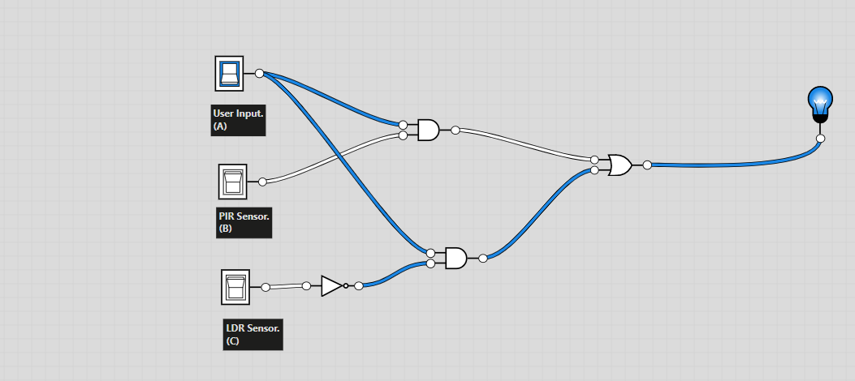

Figure 3: Logic Gate Diagram of Smart Lighting System.

From the above figure 3 illustrates the information about the different types of logic gates and its relationships between the input signals (User input, PIR Sensor and LDR Sensor) and output signals (LED). AND gate is used in smart lighting system to connect various inputs and produces an output only when all the inputs are active. In the above figure, when both the photo resistor and PIR sensor sense the suitable conditions then AND gates are used to confirm that the LED light turns on. Similarly, an OR gate is used to link different types of inputs and produces an output if at least one of the input is active. It is used to permit the user input to override these circumstances and turn the light on manually. Furthermore, a NOT gate is also known as inverter which changes the state of the input in a smart lighting system and also produces an opposite output to the input signal. It is used to reverse the output of the photo resistor switch which results that the LED turns on only when the room is dim. The second AND gate is used to confirm that the LED light turns off when the PIR sensor senses no movement in the room. By joining these logic gates, complex lighting behaviors can be accomplished in a smart lighting system. They agree for conditional and automated control of the lights based on various input factors, enhancing energy efficiency, accessibility, and customization.

# IV. Hardware and Software Implementation.

Tinkercad is an online platform which offers tools for both software and hardware design. In the context of a smart lighting system, Tinkercad can play a role in both aspects like software and hardware design. It supports in visualizing and testing the system before actual execution, which can save time and resources during the development process.

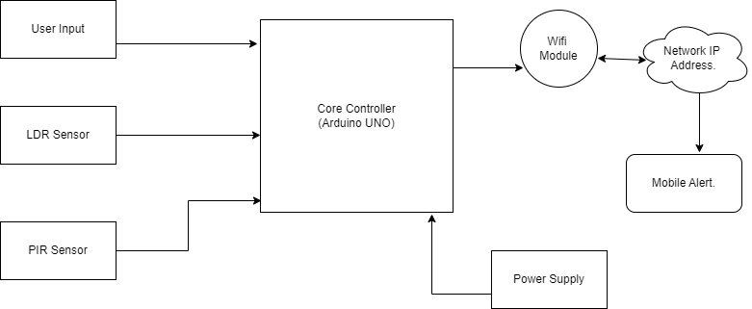

Figure 4: Block Diagram of Smart Lighting System.

The above block diagram depicts the working mechanism of smart lighting system. LDR sensor and PIR sensor are used to measure the intensity of light continuously in real time. The core controller Arduino UNO is connected to the sensors to transfer the analog signals received from the sensors into output as a digital form. The voltage provide to the Arduino UNO range between 0 to 5V. The Arduino UNO senses various signals from the given sensors, and at the end it provides the raw data into useful data. Multiple visible elements are linked to the system for user convenience. WIFI is used as ESP8266 modules. The readable data are communicated over a modern Wi-Fi network and saved in the network.

1. Component Used

Table. II Table of Component Used in Tinkercad.

|  |  |  |  |
| --- | --- | --- | --- |
| S.N. | Name | Quantity | Component |
| 1. | U1 | 1 | Arduino Uno R3 |
| 2. | U2 | 1 | Wi-Fi Module (ESP8266) |
| 3. | R1 | 1 | 1 kΩ Resistor |
| 4. | R2 | 1 | 2.2 kΩ Resistor |
| 5. | R3 | 1 | Photoresistor |
| 6. | D1 | 1 | Red LED |
| 7. | R4 | 1 | 330 Ω Resistor |
| 8. | R5 | 1 | 10 kΩ Resistor |
| 9. | PIR1 | 1 | 3.977186106672538, -201.12369637855178, -201.12369637855178 PIR Sensor |

The above table(II) depicts the components required for smart lighting system in Tinkercad. It contains of an Arduino Uno R3, a PIR sensor, a photoresistor, resistors, a red LED.

1. Hardware Requirements:
2. Arduino Uno R3:

Arduino Uno R3 is a microcontroller board which contains 6 analog inputs, a 16 MHz ceramic resonator, 14 digital input/output pins (six of which can be used as PMW outputs), a USB port, a power jack, an ICSP header, and a reset button. A microcontroller chip functions as the primary component of the open source Arduino electrical board. A microcontroller is a chip or IC (integrated circuit) that can be programmed using a computer. (Sadikin et al., 2019)

1. PIR Sensor:

PIR sensor is an electronic device which is used to detect the presence of moving objects within its range of detection. It works on the principle of infrared radiation emitted by objects. It is mostly used in smart lighting system. Pyroelectric infrared (PIR) sensors are inexpensive, low-power devices that are frequently employed in alarm and energy-saving systems. (Lai et al., 2018)

1. Photoresistor:

A photoresistor is also known as a light-dependent resistor (LDR) or photocell. The size of the light that the LDR Light Sensor (Light Dependent Resistor) receives determines how much resistance it has. It is used to measure light brightness, detect object color, and detect day or night. (Setya et al., 2019)

1. Resistor:

Resistor is defined as an electrical component which is used for controlling temperature and voltage. It is measured as ohm.

1. LED:

A Light-Emitting Diode (LED) is a semiconductor device that can emit light when an electric current passes through it. When this diode is in the forward biased condition, it can be produced light.

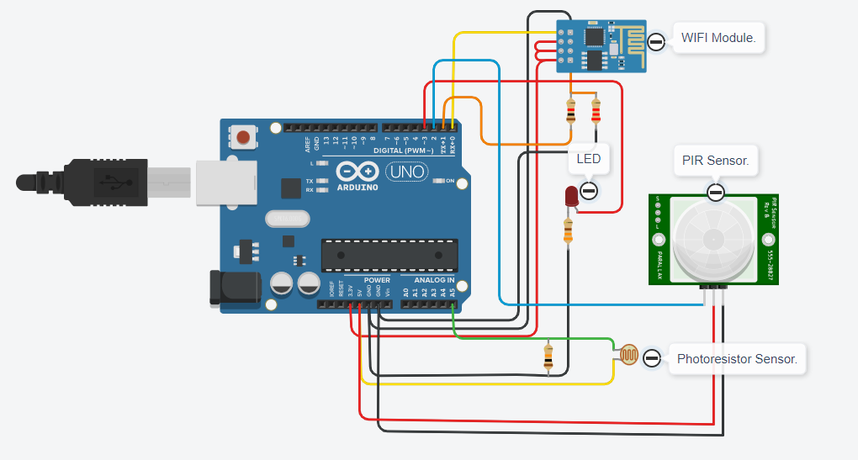

Figure 5: Circuit design of System 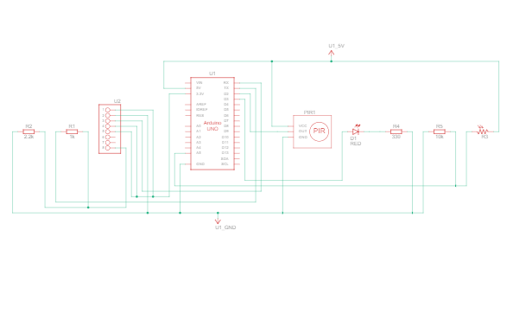 Figure 6: Schematic View of System made from Tinkercad.

An example of how electrical energy can be utilized is shown in figure 5. It demonstrates the informational flow from the PIR and photoresistor sensors to the Arduino board, which controls the LEDs in accordance with the sensor inputs. The PIR sensor recognizes motion, whereas the photoresistor sensor gauges the amount of ambient light. By regulating LED brightness, the Arduino board, which serves as the microprocessor, makes sure there is the optimum quantity of light. For the purpose of controlling current flow and safeguarding the LEDs, the system has resistors. With the ability to be controlled remotely and used hands-free, further features like a Wi-Fi module improve comfort and accessibility. A comfortable indoor atmosphere ideal for homes and companies is produced by this technology, which also considerably increases energy efficiency and lowers power costs.

# V. Conclusion and Recommendations

In summary, smart lighting systems have a lot to offer in terms of user experience, cost savings, and energy efficiency. These systems can adjust to shifting environments and user preferences by leveraging sensors, automation technology, and sophisticated control features. By turning on illumination only when necessary, the integration of motion sensors and light sensors enables efficient energy use. Convenience and accessibility are improved by integrating extra modules like Wi-Fi and voice control. Smart lighting systems are a useful option for both domestic and business applications since they can automate and remotely regulate lighting settings.

It is advised to install motion sensors in addition to light sensors to maximize energy savings and the advantages of smart lighting systems. It's essential to identify the unique requirements of each location and choose the proper fixtures and control systems. It's also advantageous to incorporate cutting-edge technologies like daylight harvesting, offer user-friendly user interfaces, and offer mobile control apps. For the system to function at its best, it is crucial to have voice control capabilities and to check and maintain it often. By adhering to these suggestions, users may take full use of the benefits of smart lighting systems, attaining energy efficiency, financial savings, and increased comfort in their interior surroundings

# VI. Security Consideration

It is crucial to put security precautions first when putting smart lighting systems in place to guard against potential weaknesses. Network security is of the highest significance and necessitates secure wireless connections, strong authentication procedures, and frequent firmware and security patch upgrades. To prevent unwanted access, it is important to install robust access control methods, such as unique, strong passwords, multi-factor authentication, and cautious user permission management.

Furthermore, it is essential to safeguard the data that smart lighting systems receive and analyze. When transmitting and storing data, encryption should be used to protect the confidentiality and integrity of sensitive data. User privacy is protected by following data protection laws and industry best practices. The security of the firmware and software used in the system should also receive attention; care should be taken to ensure that these components are purchased from reliable sources and that they are routinely updated to fix any possible security flaws.

# References

Ande, R. et al. (2020) ‘Internet of things: Evolution and technologies from a security perspective’, Sustainable Cities and Society, 54, p. 101728. doi:10.1016/j.scs.2019.101728.

Farooq, M.S. et al. (2020) ‘Role of IOT technology in agriculture: A systematic literature review’, Electronics, 9(2), p. 319. doi:10.3390/electronics9020319.

Haaker, T. et al. (2021) ‘Business Model Innovation through the application of the internet-of-things: A comparative analysis’, Journal of Business Research, 126, pp. 126–136. doi:10.1016/j.jbusres.2020.12.034.

Lai, K.-C., Ku, B.-H. and Wen, C.-Y. (2018) ‘Using cooperative pir sensing for human indoor localization’, 2018 27th Wireless and Optical Communication Conference (WOCC) [Preprint]. doi:10.1109/wocc.2018.8372703.

Lee, I. (2019) ‘The internet of things for enterprises: An ecosystem, architecture, and IOT service business model’, Internet of Things, 7, p. 100078. doi:10.1016/j.iot.2019.100078.

Molina Zarca, A. et al. (2018) ‘Enhancing IOT security through network softwarization and Virtual Security Appliances’, International Journal of Network Management, 28(5). doi:10.1002/nem.2038.

Rekha, S. et al. (2023) ‘Study of security issues and solutions in internet of things (IOT)’, Materials Today: Proceedings, 80, pp. 3554–3559. doi:10.1016/j.matpr.2021.07.295.

Roman-Castro, R., Lopez, J. and Gritzalis, S. (2018) ‘Evolution and trends in IOT security’, Computer, 51(7), pp. 16–25. doi:10.1109/mc.2018.3011051.

Sadikin, N., Sari, M. and Sanjaya, B. (2019) ‘Smarthome using Android smartphone, Arduino Uno Microcontroller and relay module’, Journal of Physics: Conference Series, 1361(1), p. 012035. doi:10.1088/1742-6596/1361/1/012035.

Shafique, K. et al. (2020) ‘Internet of things (IOT) for next-generation smart systems: A review of current challenges, future trends and prospects for emerging 5G-IOT scenarios’, IEEE Access, 8, pp. 23022–23040. doi:10.1109/access.2020.2970118.

Setya, W. et al. (2019) ‘Design and development of measurement of measuring light resistance using light dependent resistance (LDR) sensors’, Journal of Physics: Conference Series, 1402(4), p. 044102. doi:10.1088/1742-6596/1402/4/044102.

Sikder, A.K. et al. (2018) ‘IOT-enabled Smart Lighting Systems for smart cities’, 2018 IEEE 8th Annual Computing and Communication Workshop and Conference (CCWC) [Preprint]. doi:10.1109/ccwc.2018.8301744.

Čolaković, A. and Hadžialić, M. (2018) ‘Internet of things (IOT): A review of Enabling Technologies, challenges, and open research issues’, *Computer Networks*, 144, pp. 17–39. doi:10.1016/j.comnet.2018.07.017.